2019 Spring Semester LCC Graduate Students Courses Timetable
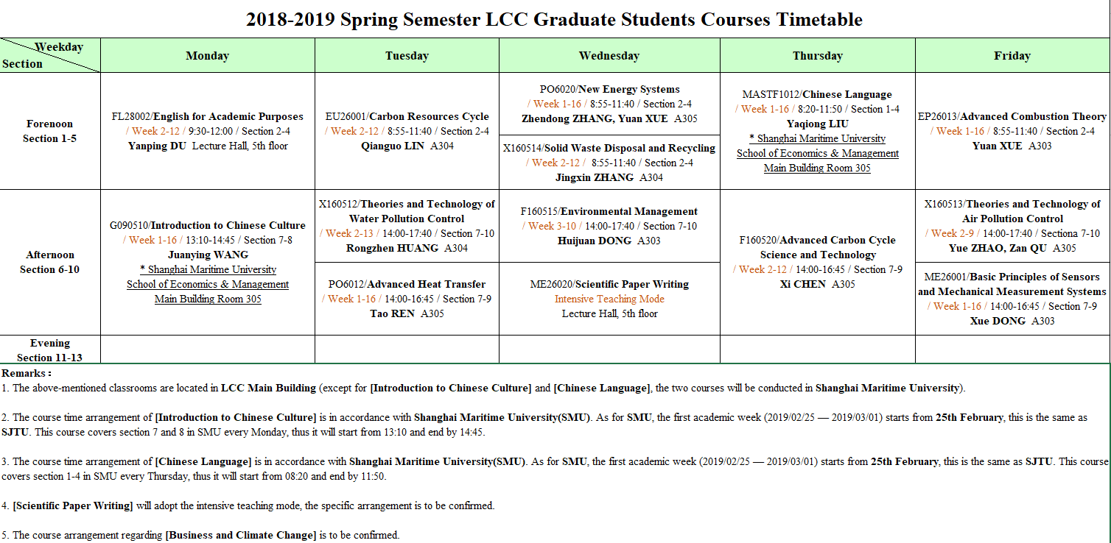

Download：2018-2019 Spring Semester LCC Graduate Students Courses Timetable

