上海交通大学硕士研究生课程教学大纲

课程基本信息（Course Information）
课程代码  （Course Code） | EU 26008 | *学时  （Credit Hours） | 32 | *学分  （Credits） |  | 2
*课程名称  （Course Name） | 碳核算
 | Carbon Accounting
课程性质  (Course Type) | 专业前沿课 Discipline Frontier Courses
授课语言  (Language of Instruction) | English
*开课院系  （School） | China-UK Low Carbon College
先修课程  （Prerequisite） | None
授课教师  （Teacher） | Haishan Yu |  | 课程网址  (Course Webpage)
*课程简介（Description） | 碳核算通过具体分析与碳排放有关的活动提供碳排放的基础数据，是应对气候变化非常重要的一部分。本课程介绍了碳核算的方法、计算、报告和审计，旨在使学生对碳核算有全面的了解，并且能够从批判的视角分析碳核算相关问题。课程从碳核算的概述开始，介绍碳核算的概念，碳核算的形式以及目的。随后，课程将从不同的层面，即国家层面、企业（或机构）层面以及产品层面对碳核算进行详细讲述，同时对各层面适用的国际通行的核算标准进行简要介绍。此后，课程将从批判的角度探讨碳信息的披露与报告，以使学生能够对当下的披露与报告实践进行系统地分析。课程还将讨论碳核算的动机、碳核算与碳金融的关系。此外，本课程还将邀请一些业界和学界的专家介绍碳核算在中国的实践情况，以帮助学生更好地理解碳核算这一理论和实践并重的课程。
*课程简介（Description） | Carbon accounting is important to efforts to tackle climate change, providing data on where emissions emanate. The course aims to provide students with an understanding of the range of measurement, calculation, reporting and auditing - in short, accounting - requirements and challenges related to climate change and the policy responses to climate change. We will begin with an overview of the different forms of carbon accounting and their different purposes. We then move to introduce the carbon accounting at different levels, covering some international standards that are popular in practice. Carbon disclosure and reporting will be discussed along with the development of analytical skills for critiquing current accounting and reporting practice. We will also explore the main motivations for carbon accounting, the relationship between carbon accounting and carbon finance, and some of the ethical issues associated with carbon accounting. In addition, guest lectures given by experienced experts from industry and academia will introduce some carbon accounting practice in China, to help students better understand the subject.
课程教学大纲（course syllabus）
*学习目标(Learning Outcomes) | On completion of this course, the student will be able to:  - Understand and critically discuss the range of measurement, calculation, reporting and auditing requirements related to climate change.  - Understand and apply methods at the forefront of carbon accounting practice.  - Explain and discuss the relationship between carbon finance and carbon accounting.  - Critically discuss the ethical questions raised by carbon and accounting.  - Understand and critically discuss the importance and implications of carbon accounting choices for effective climate change mitigation.
*教学内容、进度安排及要求  (Class Schedule  & Requirements) | Lecture 1 Introduction to Carbon Accounting: overview of the different forms of carbon accounting, and their different purposes Lecture  Lecture 2 Carbon Accounting at the national and community Level Lecture  Lecture 3 Carbon Accounting at the firm or organisational Level Lecture + in-class exercise  Lecture 4 Carbon Accounting for products and supply chains Lecture  Lecture 5 An overview of Carbon Accounting practice in China Lecture  Lecture 6 Carbon disclosure and reporting Lecture  Lecture 7 An overview of Carbon disclosure practice in China Guest Lecture  Lecture 8 Consequential carbon accounting Lecture  Lecture 9 Carbon auditing and carbon in financial accounts Lecture  Lecture 10 An overview of Carbon auditing in practice in China Guest Lecture  Lecture 11 Final Exam Exam time
*考核方式  (Grading) | - Attendance (10%)  - Group Assignment (30%)  - Exam (60%)
*教材或参考资料  (Textbooks & Other Materials) | This course is NOT a textbook course. The lectures are built upon a series of materials including accounting guidance from various organizations, academic papers, reports and other materials relevant to the course. The essential reading list will be handed out before the course kicks off. Additional readings will be given in advance of respective lectures. Most of the materials should be able to be accessed from university library either hardcopy or electronic version.
其它
（More）
备注
（Notes）

备注说明：
1.课程大纲一般为教师网上填写，填写要求会自动提示；对于新开课程，需要填着纸质大纲，并经院系教学委员会或专业委员会通过。
2．带*内容为必填项。
3．课程简介字数为300-500字；课程大纲以表述清楚教学安排为宜，字数不限。

Group Assignment:
Each group consists of 3-4 students. Each group chooses a sector or issue that they are interested in and search for a related greenhouse gas standard/method, and then work out a wiki-entry style draft about the standard. Some requirements:
  - The draft wiki entry should be no more than 500 words in length.
  - Diagrams, tables, hyperlinks, and other forms of content are encouraged.
  - The draft wiki entry must be built in 石墨（or some platform to be determined） to allow members of the group to comment/collaborate on the content before it is submitted.
Marking of the assignment:
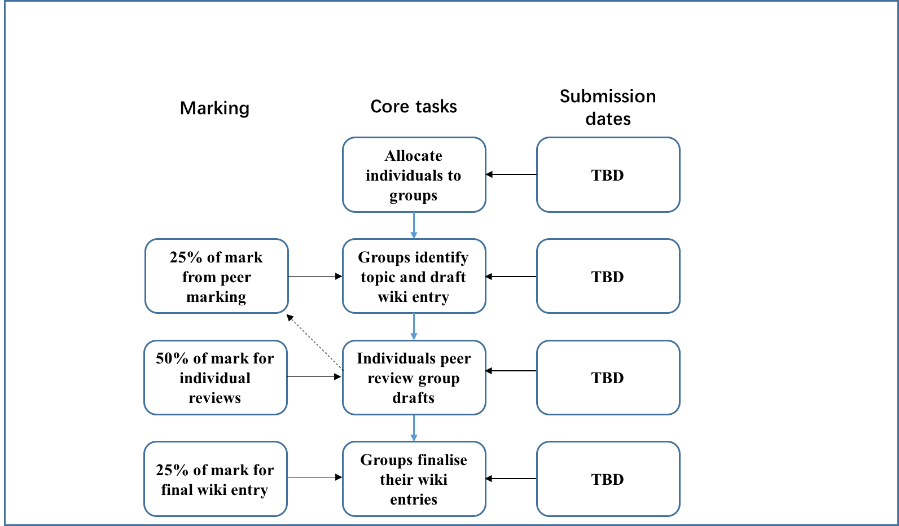
The mark of the assignment will depend on your group work and your personal review of other groups’ work.

Reading List
Reading List will be handed out before the course starts.

